**PANDUAN APLIKASI**

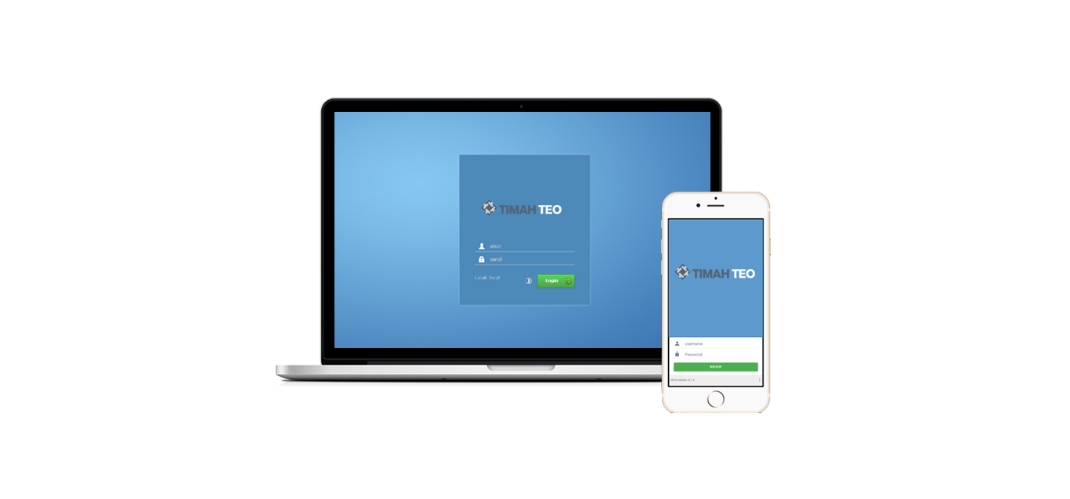**TEO**

**(TIMAH ELECTRONIC OFFICE)**

**­**

**EDISI v4.0**

**PT. TIMAH (PERSERO)**